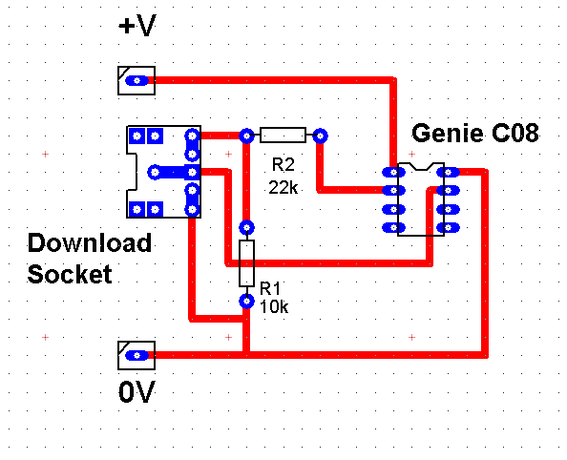
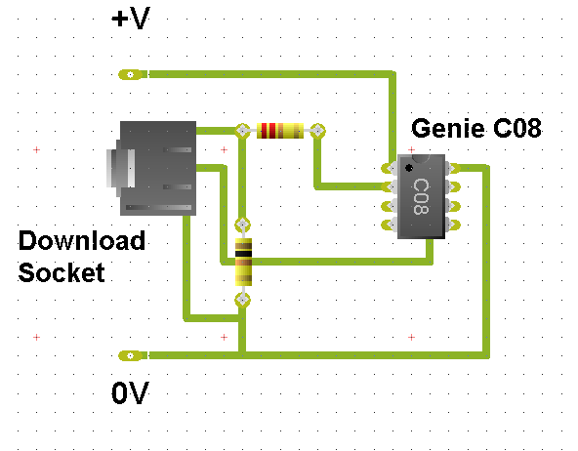
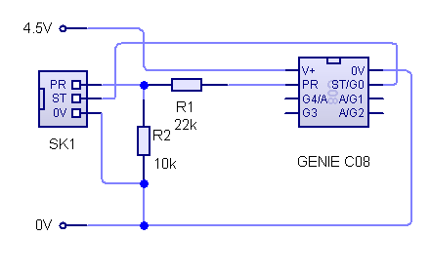
PCB Layout
Real world
view
Circuit diagram
Downloading your flowchart from your computer to your Genie 08 PIC chip
Don’t forget that the supply voltage is crucial and it must not be greater than 6Volt otherwise your Genie will be damaged forever.


Your download cable is special and contains ‘plug & play’ software. This means that you can’t use just any old USB cable. Buy yours from Rapid Electronics (part No. 13-6023)
